**Word of Life: September 2020**

*Recommended dates are provided, but you are welcome to use these materials at any time!*

**Racism Attacks Human Life**

*“My friends, we cannot tolerate or turn a blind eye to racism and exclusion in any form and yet claim to defend the sacredness of every human life”* (Pope Francis, [Special Greetings following General Audience](http://www.vatican.va/content/francesco/en/audiences/2020/documents/papa-francesco_20200603_udienza-generale.html), Wednesday, June 3, 2020).

In their November 2018 Pastoral Letter Against Racism, *[Open Wide Our Hearts: The Enduring Call to Love](http://www.usccb.org/issues-and-action/human-life-and-dignity/racism/upload/open-wide-our-hearts.pdf)*,the U.S. Catholic bishops wrote, “racism occurs because a person ignores the fundamental truth that … all [humans are] equally made in the image of God.”1 As we have seen acutely over this past year, racism fails to acknowledge the dignity with which God creates each person. Racism contributes to a culture of death. The Church in the United States has spoken out consistently against abortion, assisted suicide, euthanasia, the death penalty, and other threats to human life; it is not a secret that these attacks severely affect people of color. Following the death of George Floyd, the bishops and Catholic organizations again raised their voices against this attack on human life through public Masses, statements, and calls to prayer.

The feast of St. Peter Claver is an opportunity to highlight the connection between racism and various attacks against human life. As St. John Paul II reminded us, “*Where life is involved, the service of charity must be profoundly consistent.* It cannot tolerate bias and discrimination, for human life is sacred and inviolable at every stage and in every situation; it is an indivisible good”2 (emphasis added). Additional [parish resources for combatting racism](http://www.usccb.org/issues-and-action/human-life-and-dignity/racism/parish-resources-on-racism.cfm) are available online.

1 USCCB, *Open Wide Our Hearts: The Enduring Call to Love*, 4.

2 Pope Saint John Paul II, *Evangelium vitae* (Vatican City: Libreria Editrice Vaticana, 1995), no. 87.

Excerpt from *Evangelium vitae*, © 1995, Libreria Editrice Vaticana. Used with permission. All rights reserved.

**September 9, 2020**

**Memorial of Saint Peter Claver, Priest  
National Day of Prayer for Peace in Our Communities**

We invite you to pray through the readings for the Memorial of St. Peter Claver, which can be accessed at <https://bible.usccb.org/bible/readings/090920.cfm>.

The U.S. Catholic bishops suggest that parishes “could use the National Day of Prayer for Peace in Our Communities, which falls on the feast of St. Peter Claver (September 9), to organize activities that foster community, dialogue, and reconciliation. These encounters will help open our minds and hearts more fully and continue the healing needed in our communities and our nation.”1

All are invited to pray with the following resources:

* [Prayer Service for the Feast Day of St. Peter Claver](http://www.usccb.org/issues-and-action/human-life-and-dignity/racism/upload/peter-claver-prayer-service-color.pdf)
* [Prayer for Peace in Our Communities](http://www.usccb.org/issues-and-action/human-life-and-dignity/racism/upload/16-056-prayer-for-peace-prayer-card.pdf)
* [Prayer of the Faithful for the Day of Prayer for Peace in Our Communities](http://www.usccb.org/issues-and-action/human-life-and-dignity/racism/prayer-of-the-faithful-day-of-prayer-for-peace-in-our-communities.cfm)

1 USCCB, *Open Wide Our Hearts: The Enduring Call to Love*, 25.

**Word of Life – September 2020**

**Intercessions for Life**

|  |  |
| --- | --- |
| **September 6th**  May the life of every human person, from conception to natural death, be protected in our laws  and cherished in our hearts;  *We pray to the Lord*: | **Twenty-third Sunday  in Ordinary Time** |
| **September 13th**  For solidarity and peace  in our global human family:  that we may work together  to protect the lives of those  who are most vulnerable;  *We pray to the Lord:* | **Twenty-fourth Sunday  in Ordinary Time** |
| **September 20th**  For all whose hearts ache  from participating in abortion: may they be strengthened to seek  the Lord’s compassion, mercy, and healing  in the Sacrament of Reconciliation;  *We pray to the Lord:* | **Twenty-fifth Sunday  in Ordinary Time** |
| **September 27th**  For all who are forgotten or cast off,  especially the unborn, the poor, the sick, and the aged:  may they be treated according to the dignity with which God created them;  *We pray to the Lord:* | **Twenty-sixth Sunday  in Ordinary Time** |
|  |  |

**Bulletin Quotes**

|  |  |
| --- | --- |
| **September 6th**  “The Church has consistently taught that every human life is precious and worthy of protection.”  USCCB Secretariat of Pro-Life Activities  “Another Look at Abortion” | [Order](http://store.usccb.org/another-look-at-abortion-p/c1841.htm) | [Download](http://www.usccb.org/about/pro-life-activities/respect-life-program/2018/upload/rlp-18-eng-color-another-look-at-abortion-secure.pdf) |
| **September 13th**  “By our baptism, we are members of Christ’s body and sharers in his mission. Imitating Christ, we must care for all members of our communities, honoring each person as unique, sacred, and created in the image of God.”  USCCB, “Open Wide Our Hearts” Bulletin Insert | [Download](http://www.usccb.org/issues-and-action/human-life-and-dignity/racism/upload/open-wide-our-hearts-bulletin-insert.pdf) |
| **September 20th**  “Throughout salvation history, God has welcomed repentant sinners with special joy. Jesus concludes the parable of the lost sheep with these words: ‘there will be more joy in heaven over one sinner who repents than over ninety-nine righteous people who have no need of repentance’ (Lk 15:7)*.”  *\*NABRE © 2010 CCD. Used with permission.*  USCCB Secretariat of Pro-Life Activities  “Life Matters: Forgiveness and Healing After Abortion” | [Order](https://store.usccb.org/life-matters-p/c1344.htm) | [Download](http://www.usccb.org/about/pro-life-activities/respect-life-program/2013/upload/2013-Life-Matters-Forgiveness-And-Healing-After-Abortion-secured.pdf) |
| **September 27th**  “Suicidal individuals—with or without a terminal illness—typically do not want to die… The patient requesting assisted suicide is often asking, ‘Does anyone want me to be alive, or care enough to talk me out of this request and support me through this difficult time?’”  USCCB Secretariat of Pro-Life Activities  “Every Suicide is Tragic” | [Order](http://store.usccb.org/Every-Suicide-Is-Tragic-p/c1643.htm) | [Download](http://www.usccb.org/about/pro-life-activities/respect-life-program/2016/upload/rlp-16-flyer-every-suicide-is-tragic.pdf) |

**Word of Life - September 2019**

**Bulletin Art**

*You are welcome to use these, provided they are not altered in any way, other than the size. Thank you!*

**Sunday, September 6th, 2020**

* 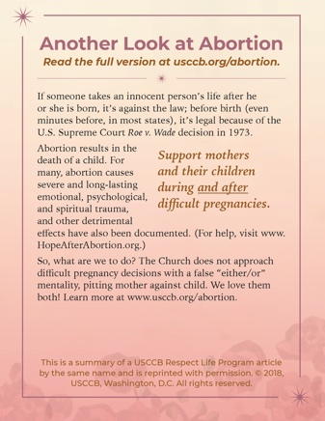Bulletin Box (Color): [English](http://www.usccb.org/about/pro-life-activities/respect-life-program/2018/upload/rlp-18-abortion-color-4-25-eng.jpg) | [Spanish](http://www.usccb.org/about/pro-life-activities/respect-life-program/2018/upload/rlp-18-abortion-color-4-25-sp.png)
* Bulletin Box (Grayscale): [English](http://www.usccb.org/about/pro-life-activities/respect-life-program/2018/upload/rlp-18-abortion-grayscale-4-25-eng.jpg) | [Spanish](http://www.usccb.org/about/pro-life-activities/respect-life-program/2018/upload/rlp-18-abortion-grayscale-4-25-sp.png)

**Sunday, September 20th, 2020**

* 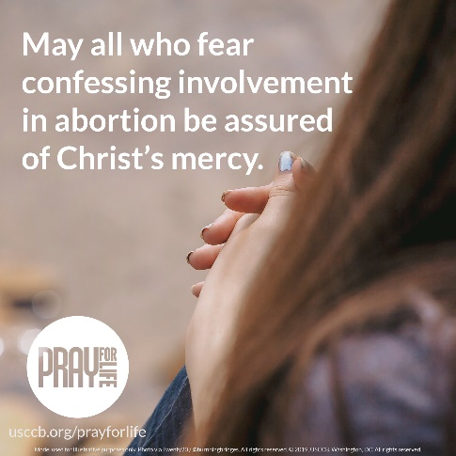Image: [English](http://www.usccb.org/about/pro-life-activities/upload/prayforlife-04-2019.png) | [Spanish](http://www.usccb.org/about/pro-life-activities/prayers/upload/prayforlife_04-2019-sp.png)

**Sunday, September 27th, 2020**

* 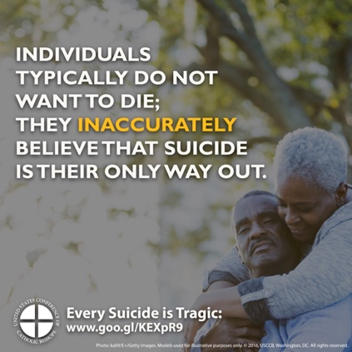Image: [English](http://www.usccb.org/about/pro-life-activities/respect-life-program/2016/upload/rlp-16-shareable-image-suicide-2.jpg) | [Spanish](http://www.usccb.org/about/pro-life-activities/respect-life-program/2016/upload/rlp-16-shareable-image-suicide-2-spa.jpg)